Faking It: Originals, Copies, and Counterfeits
The Museum at FIT
Fashion & Textile History Gallery
December 2, 2014 – April 25, 2015
All photographs © The Museum at FIT

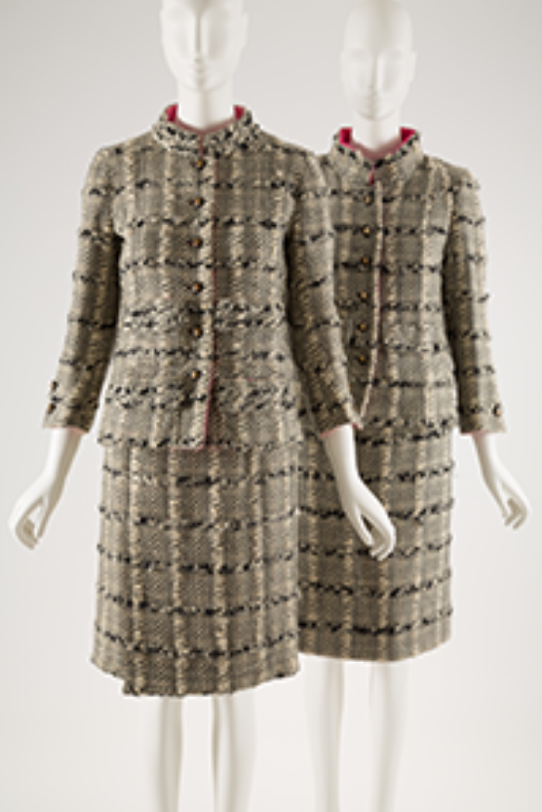
L to R:
Gabrielle “Coco” Chanel
Day suit
Wool bouclé
1966
France
Gift of Eleanor K. Graham
Licensed copy of a Chanel day suit
Wool bouclé
c. 1967
USA
Gift of Ruth L. Peskin
•
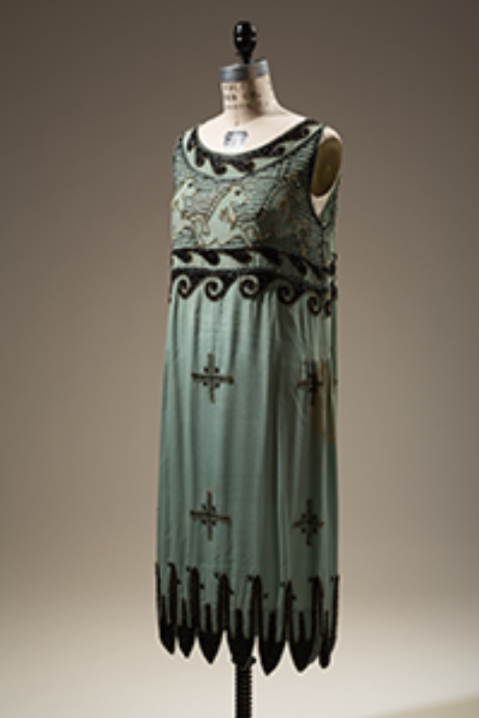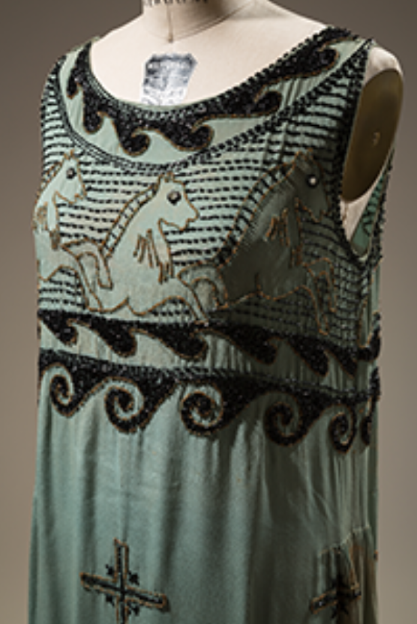
Unlicensed copy of Madeleine Vionnet’s “Little Horses” dress
rayon crepe, black and gold seed beads
c. 1925
USA
Gift of Mrs. J. Mirsky
•
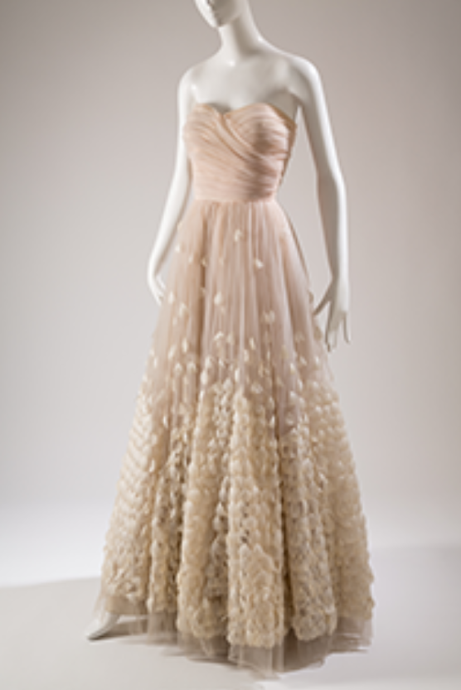
Licensed copy of Pierre Balmain’s Angel evening dress
Created by Orcilia in Santiago de Cuba
Tulle, feathers
1946-1947
Cuba
Gift of Molly Milbank
•
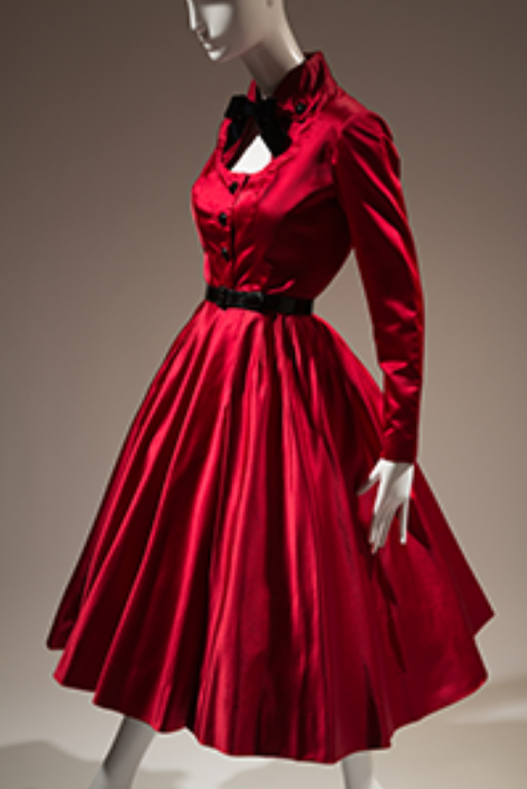
Jacques Fath for Joseph Halpert
Cocktail dress
Fall 1952
Silk satin
USA
Museum purchase
•
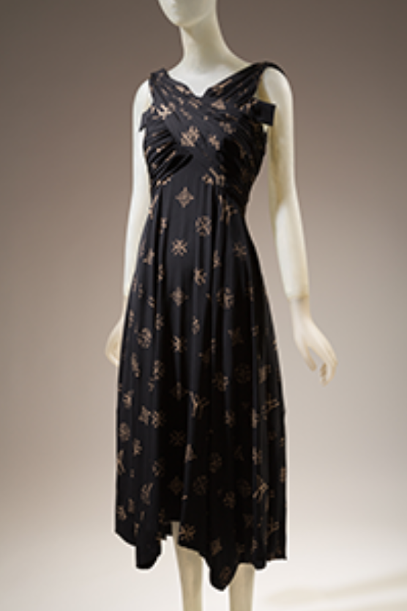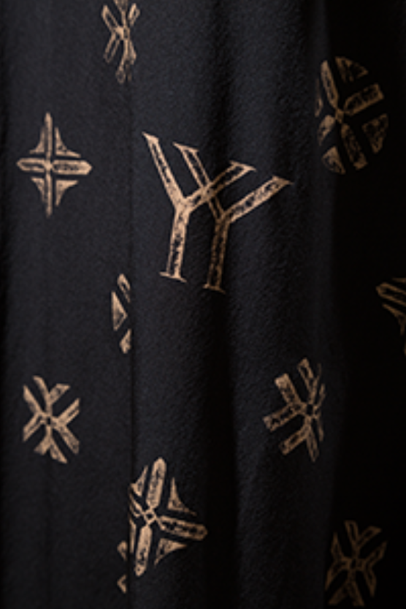
Yohji Yamamoto
Dress
Fall 2007
Silk
Japan
Museum Purchase
•
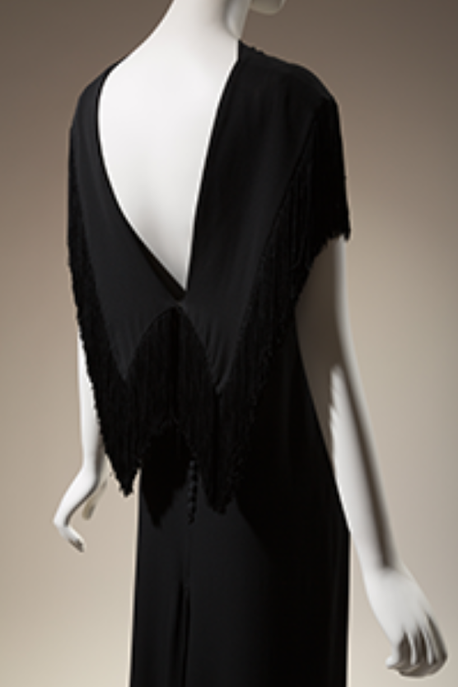
Evening dress registered with the Fashion Originators Guild of America
1933-1935
Rayon crepe
USA
Anonymous Donor
•
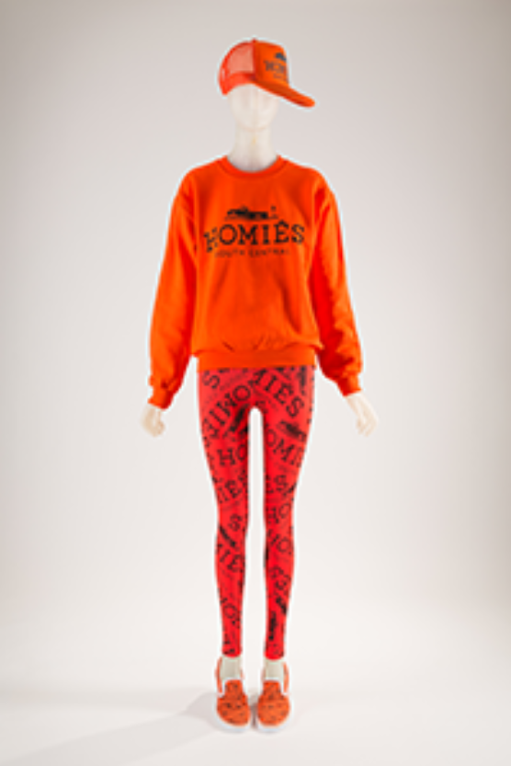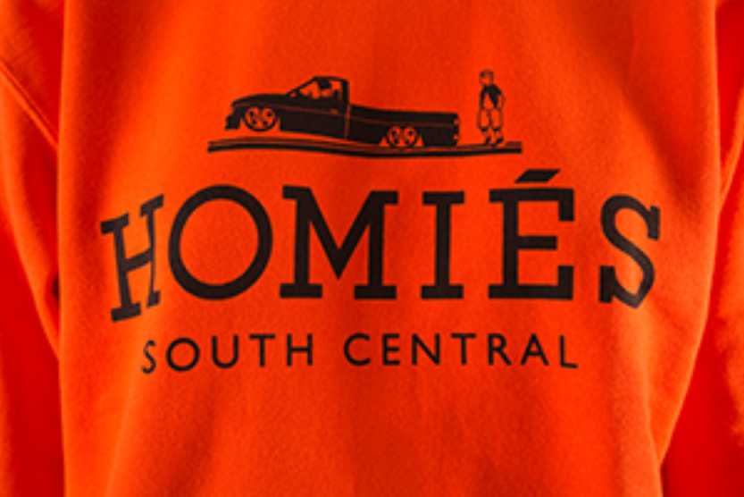
Brian Lichtenberg
“Homiés” ensemble
2014
Cotton, polyester, rubber
USA
Gift of Brian Lichtenberg Studio
•
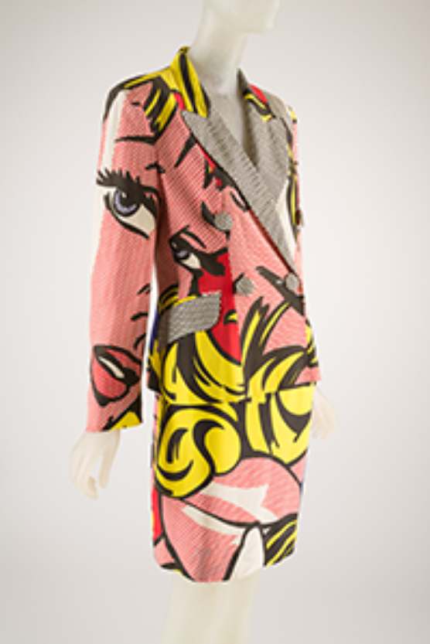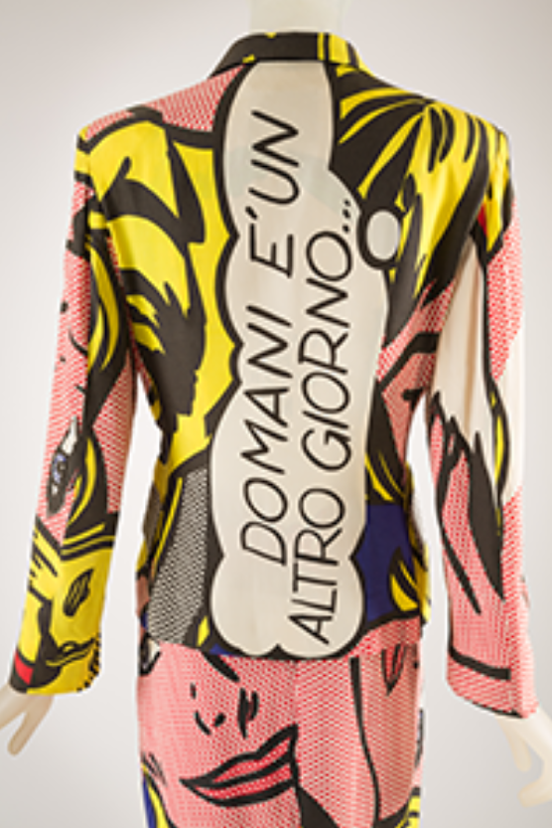
Moschino Cheap and Chic
Suit with Roy Lichtenstein print
1991
Acetate, rayon
Italy
Museum purchase
•
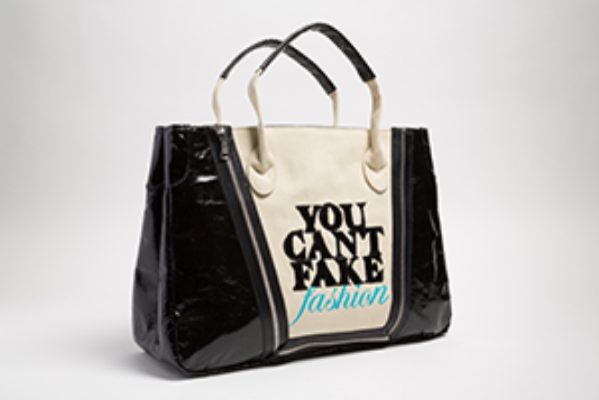
Catherine Malendrino
“You Can’t Fake Fashion” eBay x CFDA anti-counterfeit campaign
Tote
2013
Vinyl, cotton, zipper
USA
Gift of eBay
•
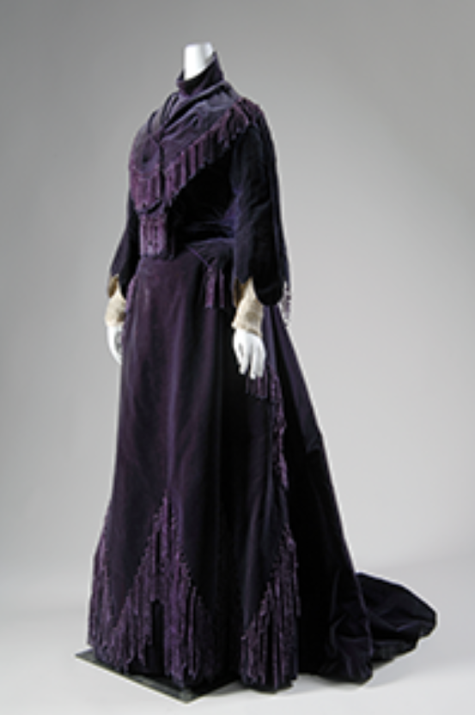
The House of Worth
Afternoon dress
Silk velvet, chenille, chiffon
1903
France
Gift of Mary Elizabeth Fogarty
•
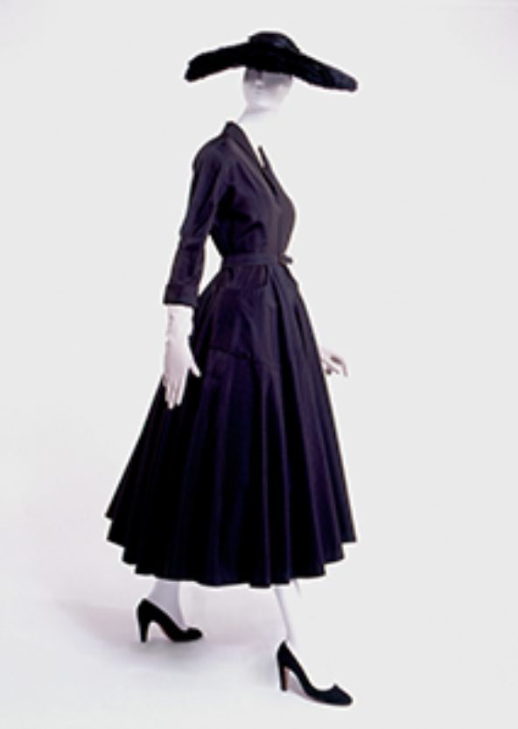
Nettie Rosenstein
Dress
Silk/wool faille, horsehair
1947
USA
Gift of Janet Chatfield-Taylor
•
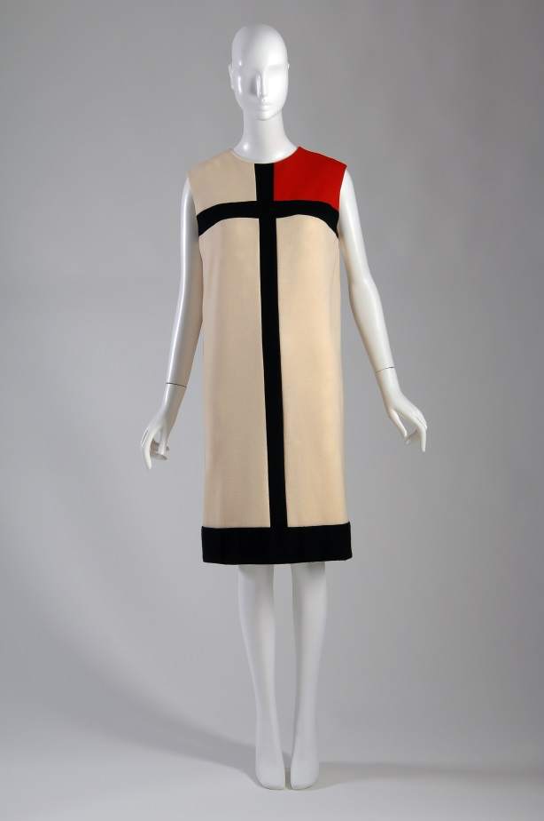

Yves Saint Laurent
“Mondrian” dress
Wool jersey
1965
France
Gift of Igor Kamlukin from the Estate of Valentina Schlee

