FASHION FORECAST
WGSN
KEY ITEMS FOR A/W 18/19
WOMENSWEAR
Sara Maggioni, Director of Retail & Buying, WGSN

Every season, WGSN publishes comprehensive Buyers’ Briefings across all product categories to provide a complete guide to buying and range planning. We use a combination of diverse sources to help achieve the right balance of newness and commerciality.

MARKETS ARE BLURRED: the blurring of genres and genders, the cross-pollination of categories and the growing importance of hi-lo styling will be a key message for A/W 17/18, going hand-in-hand with the ongoing focus on layered styling. Tailoring, sportswear and decorative designs are mixed harmoniously, infiltrating all levels of the market. Menswear influences are much more natural and less contrived than in previous seasons, while velvet, satin and brocade are increasingly used within a casualwear context. Ideas about age are also changing – 30 is the new 20, and 40 is the new 30 – and with this, a new youthful focus is affecting fashion as formal and streetwear brands blur: hoodies, T-shirts and jersey basics become fashion items, mixed with more tailored/formal design for all-important high/low looks.

TRANSSEASONAL & SEASONLESS: The focus on transseasonal items, seasonless designs and layered styling remains an essential message. Just like the cross-pollination of genres, cross-seasonal appeal is becoming increasingly important, with typical S/S patterns, colours and items emerging for A/W collections and vice versa. The S/S 17 catwalks were an obvious testament to this, with metallic finishes, brocades and opulent historical references normally associated with winter and party deliveries populating collections. Outerwear is one of the categories most impacted: we are seeing lighter-weight coats such as dusters and trenches proliferate at retail, just as fur coats decline slightly.

MAXIMALISM: Gucci’s more-is-more approach to dressing (also known as Maximalism) will continue. As well as this really decorative theme (think brocade, velvet, dressing up box style clothing, embroidery, jewel-encrusted accessories, historical references etc.) it will start to also merge with a clean, minimalist look for a fresh and more wearable direction – think sculpted ruffles, flared hems and oversized details, with designers such as Ellery, Beaufille and Rosie Assoulin as key references. Colour also plays a big part in this story, with bold solid tones emerging as an important message for A/W 17/18.

MODERN LEISURE & FEMININE SPORTS: Sportwear influences are not going away any time soon. We are expecting two main directions. For the younger market, feminine and girly elements are mixed with sporty and 90s looks through both styling and details for newness: boudoir dresses are layered over branded tees, lace trims soften track jackets, pretty floral dresses are worn over hoodies and sporty elasticated straps are mixed with ruffled dresses. For the contemporary consumer, sportswear-influenced references are fused with modern design elements, creating a futuristic and abstract appeal with an easy-to-wear attitude.

80S INFLUENCES : Having made a big comeback on the catwalks over the past couple of seasons, 1980s references infiltrate collections with elements such as power shoulders, metallic finishes, vinyl fabrics and skintight basics nodding to the era. While literal, brash, head-to-toe styling might not take hold at commercial level, 1980s-inspired elements will certainly trickle down to the high street, particularly for party deliveries but also tapping into all-important high/low styling stories. Bodycon party dresses and Lycra basics offer a new silhouette after so many seasons of oversized proportions – and are key to updating popular streetwear and 1990s looks.

MODERN UTILITY: Utility and military themes continue to reinvent themselves season after season across both women's and men's. A pared-back contemporary take refreshes this popular trend for A/W 17/18, with oversized pockets and details also tapping into minimalist-maximalism territory. Boxy silhouettes, ultra-clean finishes and sophisticated tones of tobacco, pale khaki and ecru are essential, with tonal styling looking particularly strong. Marni’s S/S 17 collection is a key influencer here, alongside newcomers such as Ricostru and Aalto.

FAR EAST: A more directional look, but one worth keeping an eye on for party and eveningwear: Eastern influences have been recently infiltrating editorials and street style, with chinoiserie motifs, qipao-inspired dresses and cheongsam tops and jackets making a first appearance. Led by the likes of Gucci as well as up-and-coming brands such as Attico and Alessandra Rich, this fresh story carries forward boudoir and loungewear-inspired dressing as well as current favourites embroidery, satin finishes, high necklines and souvenir jackets. Details such as mandarin collars, frog buttons and piping are applied to contemporary shapes for a more accessible look, as seen at Reformation and Prada.

For more information about how to access insight and inspiration from WGSN, visit wgsn.com

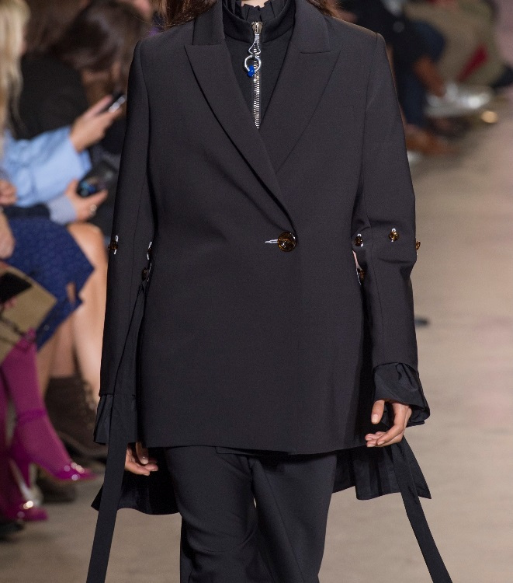
Ellery Paris, S/S 17
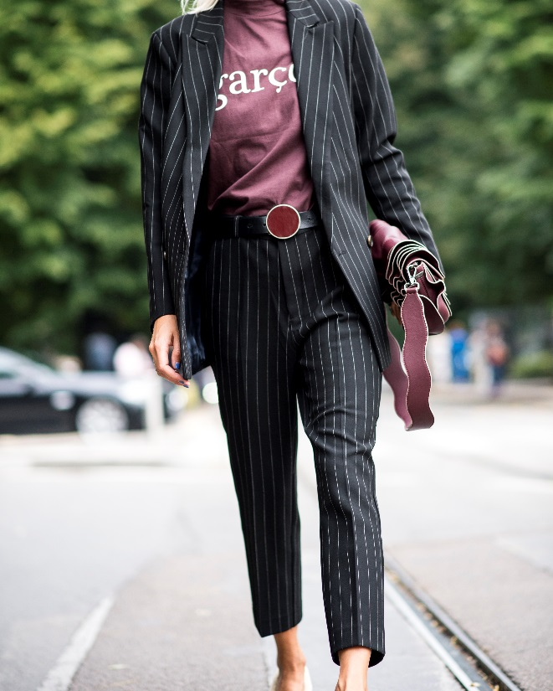
Milan Fashion Week Streets, 2016

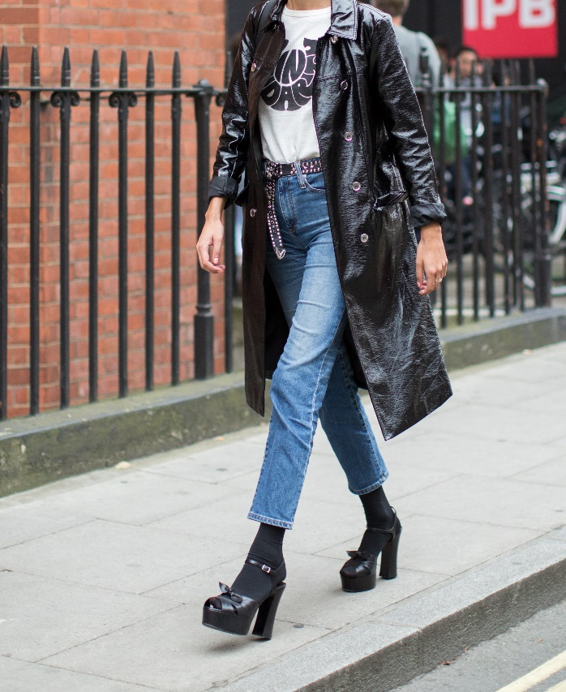
London Fashion Week Streets, 2016

Images courtesy of © WGSN Limited. 2017. All rights reserved.

