FASHION FORECAST
WGSN
KEY ITEMS FOR A/W 17/18
WOMENSWEAR
Sara Maggioni, Director of Retail & Buying, WGSN

Every season, WGSN publishes comprehensive Buyers’ Briefings across all product categories to provide a complete guide to buying and range planning. We use a combination of diverse sources to help achieve the right balance of newness and commerciality.

MARKETS ARE BLURRED: the blurring of genres and genders, the cross-pollination of categories and the growing importance of hi-lo styling will be key messages for A/W 17/18, together with the ongoing focus on layered styling. Tailoring, sportswear and decorative designs are mixed harmoniously. Menswear influences are less contrived than in previous seasons, while velvet, satin and brocade are increasingly used within a casualwear context. Ideas about age are also changing – 30 is the new 20, and 40 the new 30; a new youthful focus is affecting fashion as formal and streetwear brands blur: hoodies, T-shirts and jersey basics become fashion items, mixed with more tailored/formal design.

TRANSSEASONAL & SEASONLESS: The focus on transseasonal items and layered styling remains an essential message, with typical S/S patterns, colors and items emerging for A/W collections and vice versa. The S/S 17 catwalks were testament to this, with metallic finishes, brocades and opulent historical references normally associated with winter deliveries. Outerwear is one of the categories most impacted: lighter-weight coats such as dusters and trenches proliferate in retail as fur coats decline.

MAXIMALISM: Gucci’s more-is-more approach to dressing will continue. As well as this decorative theme (brocade, velvet, embroidery, jewel-encrusted accessories, historical references, etc.) it will also start to merge with a clean, minimalist look for a fresh and more wearable direction – think sculpted ruffles, flared hems and oversized details. Color also plays a big part in this story, with bold, solid tones emerging as a pivotal theme.

MODERN LEISURE & FEMININE SPORTS: Sportswear influences are still strong. For the younger market, feminine and girly elements meet sporty and 90s looks – a style fusion that is brought bang up to date through both the styling and details: boudoir dresses are layered over branded tees, lace trims soften track jackets, pretty floral dresses are worn over hoodies and sporty elasticated straps are paired with ruffled dresses. For the contemporary consumer, sportswear influences are fused with modern design elements, creating a futuristic and abstract appeal.

80S INFLUENCES: The 1980s continue to infiltrate collections with elements such as power shoulders, metallic finishes, vinyl fabrics and skintight basics in a nod to the era. While literal, brash, head-to-toe styling might not take hold at commercial level, 1980s-inspired elements will certainly trickle down to the high street, particularly for party deliveries. Bodycon party dresses and Lycra basics offer a new silhouette after so many seasons of oversized proportions – and are key to updating popular streetwear and 1990s looks.

MODERN UTILITY: Utility and military themes continue to reinvent themselves season after season across both womenswear and menswear. Boxy silhouettes, ultra-clean finishes and sophisticated tones of Tobacco, pale Khaki and Ecru are essential, with tonal styling looking particularly strong.

FAR EAST: A more directional look, but one worth keeping an eye on for party and eveningwear: Eastern influences have recently been permeating editorials and street style, with chinoiserie motifs, qipao-inspired dresses and cheongsam tops and jackets making a first appearance. Led by Gucci, as well as up-and-coming brands such as Attico and Alessandra Rich, this fresh story carries forward boudoir and loungewear-inspired dressing as well as embroidery, satin finishes, high necklines and souvenir jackets. Details such as mandarin collars, frog buttons and piping are applied to contemporary shapes for a more accessible look.

For more information about how to access insight and inspiration from WGSN, visit wgsn.com

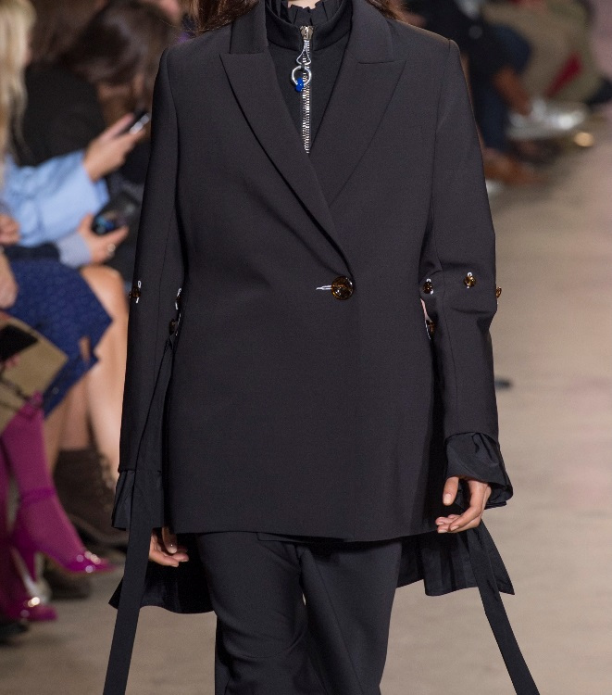
Ellery Paris, S/S 17
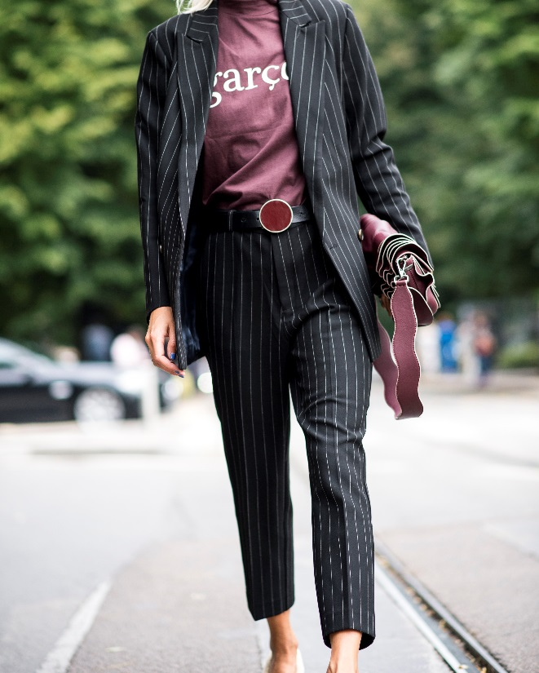
Milan Fashion Week Streets, 2016

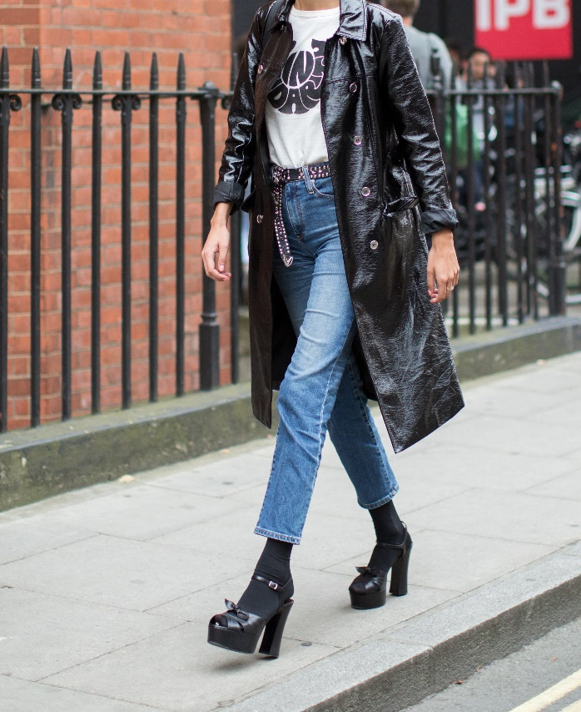
London Fashion Week Streets, 2016

Images courtesy of © WGSN Limited. 2017. All rights reserved.

