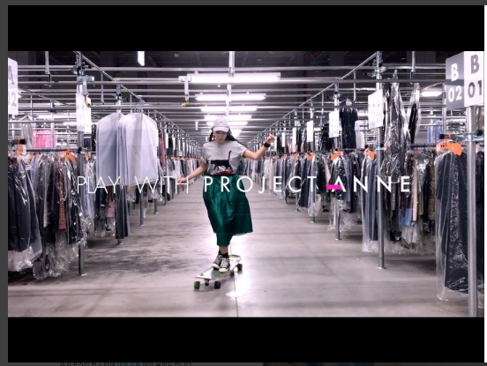https://youtu.be/5r2b7kY-ByM (storage)
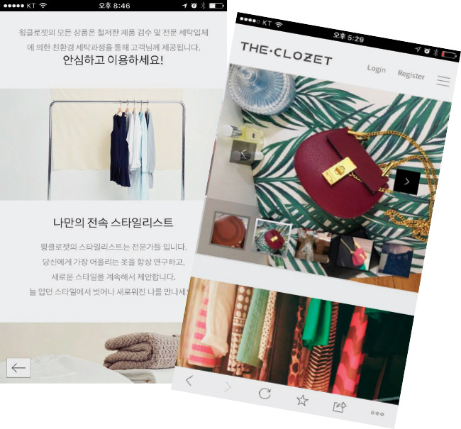
They said that this is just the capturing of the smart phone.

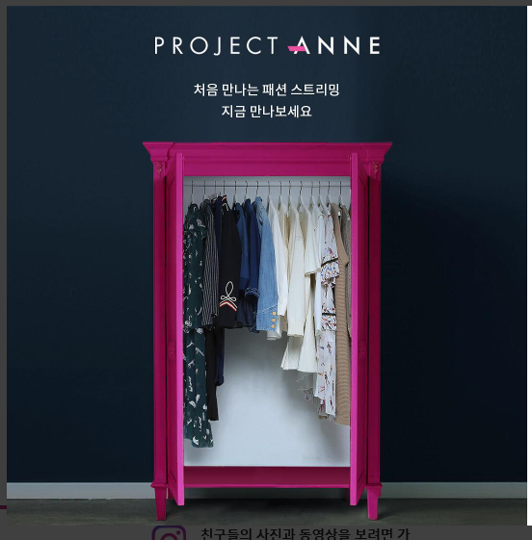
(I got some images from them like this, but it might not be able to use for the magazine…)
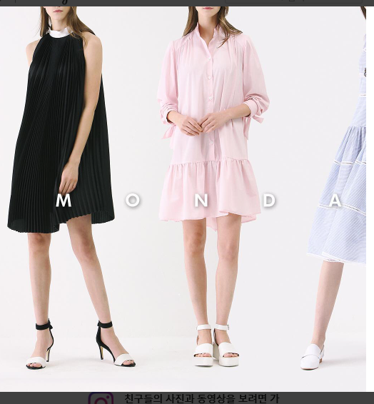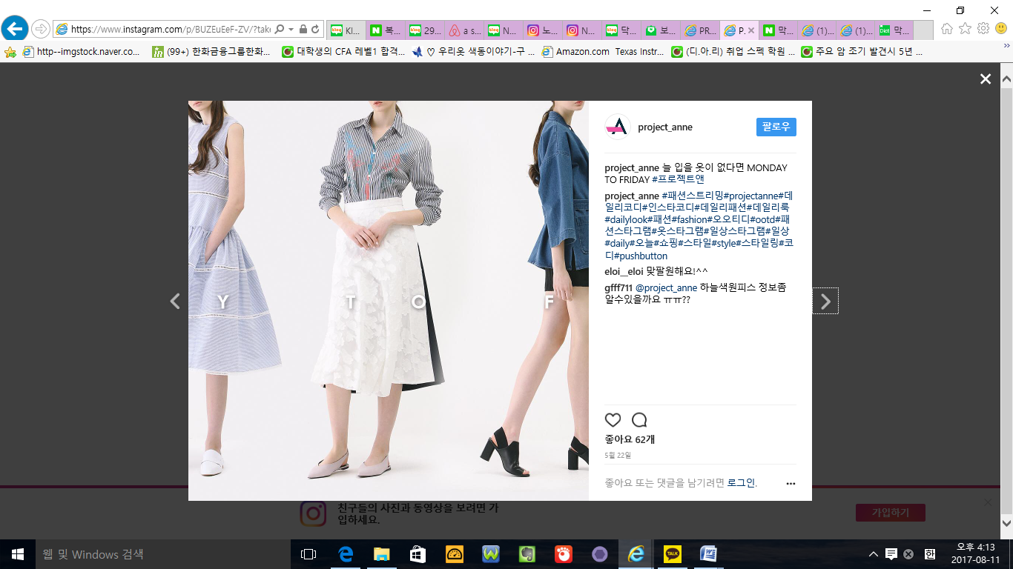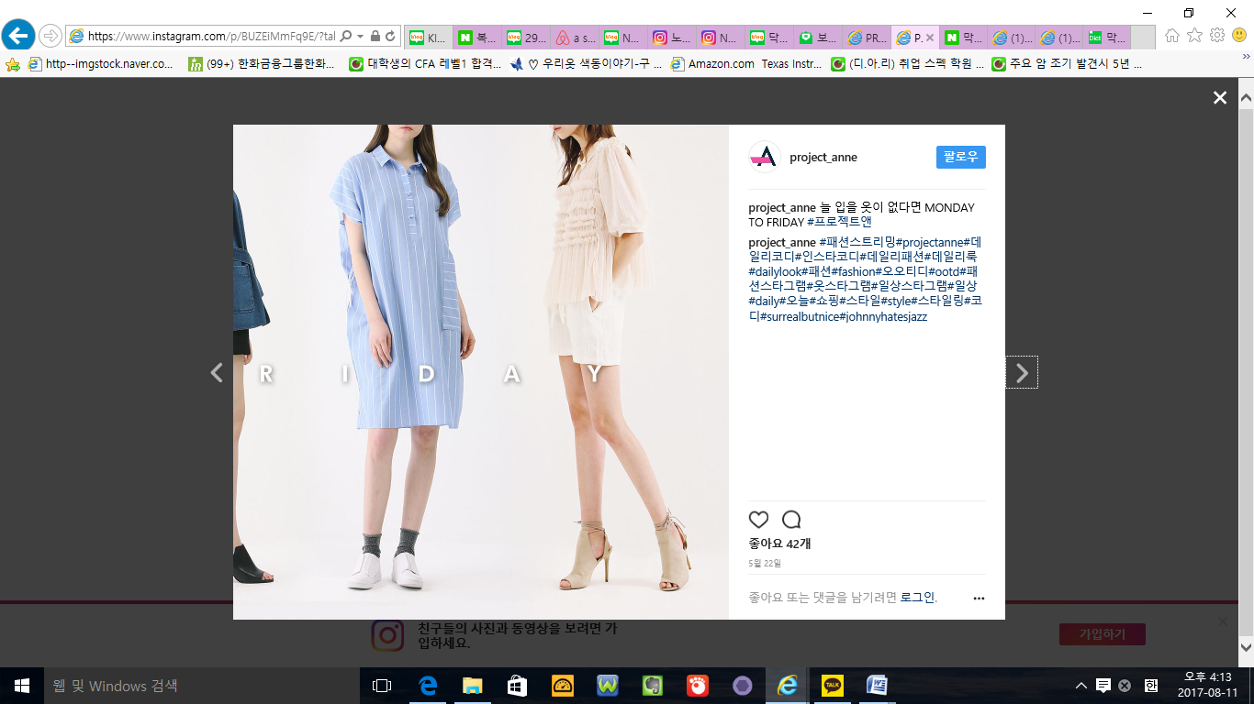
Maybe we can edit image using the pictures(download from the link) as avobe.
https://www.dropbox.com/sh/62kmu2kupty5qlq/AADH5FEBuTdonGh444IwXMG-a?dl=0
https://www.dropbox.com/sh/xwn8gi15zx113l7/AAArraB3Uy3jeBLS9HNT1zDXa?dl=0
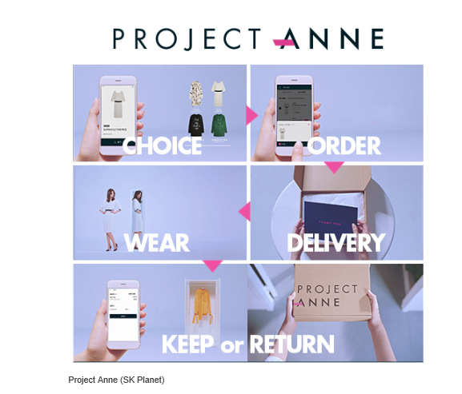
I asked them the images as above. But they said that this is made from video file(by screen capturing)
Is it possible that using images from the video? I know it is not so great way but I think that it could be possible… because each picture’s size is not so big, so maybe is it enough to use not-so-high-resolution pictures for that? I was just thinking about that.
https://youtu.be/5halYM1QZGE (TUTORIAL) https://youtu.be/5r2b7kY-ByM (storage)
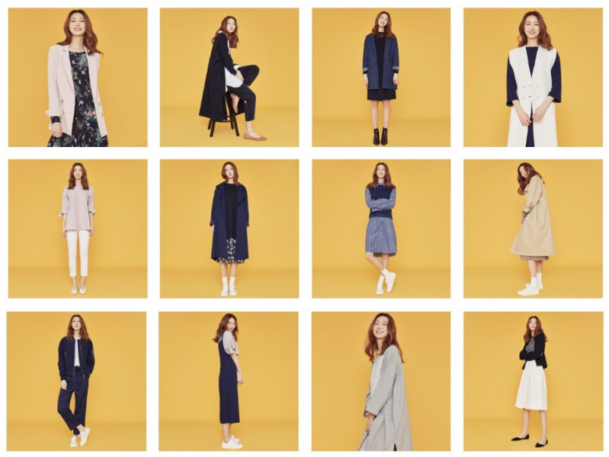
Another way I thought is display pictures they gave us like above and add some praise on it. (eg. Project Anne, don’t buy but use it – fashion streaming, etc.) I think it is possible to display whatever ways as we want, they just want to see how it will be printed before the issue.(So they can pre-discuss with the agency and pay them if it is necessary, for the copyright and portrait right of the pictures. The latent expense is on the company, not on us.)

